Agile Practices and Improvements Based on Feedback

Contents

Introduction 3

Personal Project Overview and Selection 3

Feedback Integration and Agile Practices 3

Significant feedbacks and turning points 4

Conclusion 6

# Introduction

This document serves as a demonstration of my personal leadership and how I am able to plan during this semester, request feedback from my teachers, and implement changes based on that feedback. I will do so by giving information of my agile practices.

# Personal Project Overview and Selection

After a hard thought about the project options, I had 3 initial ideas, which after discussing them with my technical teachers proved all of them to be suitable to showcase my proficiency in all of the learning outcomes. I chose the collaborative movie selection application, because I personally liked it the most. This project is something that is not seen often and it had allowed me to apply and demonstrate the learning outcomes effectively.

# Feedback Integration and Agile Practices

From the beginning of the semester I started working in agile. Since I was part of a group that works on a project for method optimization for ASML, our work plan was to work in agile. We created a Jira board and agreed to do daily stand ups for the project. For my individual project I did the same, but with my teachers. In stead of having daily standups with my groupmates, they were with my teachers and created an individual board on Trello, where I put all of the tasks for my individual project.

The daily standups with my technical teachers were documented on FeedPulse where I put my notes from the meeting and I get a grading based on emojis on whether I am on track with the progress or lacking behind.

## Significant feedbacks and turning points

The first half of the semester was not very productive for me, because I had underestimated the workload for the semester and the projects. 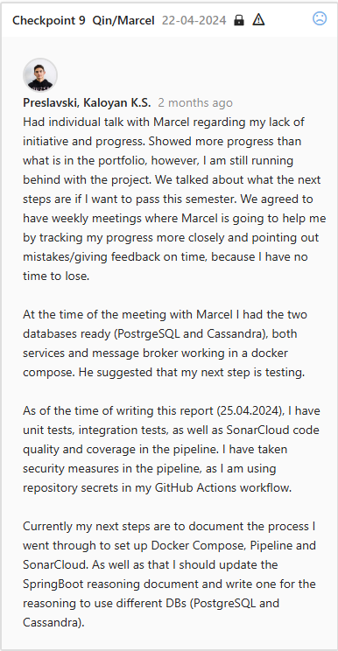

Early on I had received feedback regarding my scalability and data management which was lacking proper reasoning. One of my mistakes during the first part of the semester was that I did not have enough reasoning for the choice of a technology, architecture design, or any other choice that I had to do. This was acknowledged by me after a personal meeting that I had with Marcel regarding not only that, but also my lack of initiative and the fact that I was falling behind. After that I did extensive research on the technologies that I have used, more in particular the choice to use two databases – Cassandra and PostgreSQL. The result of the research and the tips of Marcel lead me to the conclusion that this is not necessary and my application will be working sufficiently with just the Cassandra database.

Another critical feedback that I received was from Nicole and it was regarding the evidence and my progress for the first two learning outcomes. I was lacking a lot of evidence for the learning outcomes, this leading to the “Orienting” grading for them in my portfolio delivery. After that comment and feedback, I started working on my research documents, design document, ethical documents, graduation preparation document and the creation of this document.

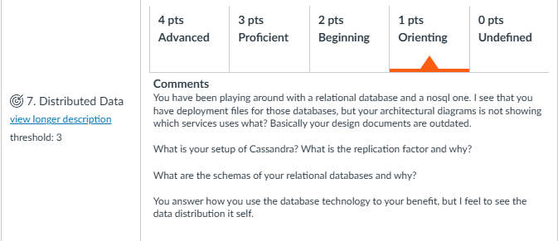

This feedback was received for my third portfolio delivery. It highlights the need for clearer architectural documentation and updated system configurations. I made significant changes to the project’s data base management strategy. The initial plans were to use Cassandra for the Voting Service and PostgreSQL for the Favorites Management Service. I had decided to go with this approach because of Cassandra’s high throughput and PostgreSQL’s strong transactional integrity for structured data. After analyzing Movimingle's requirements and use cases, I determined that using two different databases was unnecessary and complex. The reasoning behind that is that Movimingle does not need strict transactional integrity for sensitive financial or medical data. The user profiles and movie lists do not require PostgreSQL’s rigorous consistency and transactional guarantees. As well as that, the management of several database systems adds complexity to the system design by having to do additional configuration, monitoring, and backup processes. Cassandra, a NoSQL database, efficiently manages both voting and movie data. In theory, it can scale and operate well for a huge user base. Testing the performance difference between utilizing a single database and the existing arrangement is necessary to establish the optimal solution.

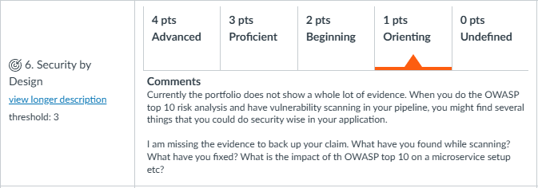

This feedback was given to me because of the lack of detailed security measures and vulnerability assessments for the project. The measures that I have taken based on this were to create an OWASP Top 10 risk analysis in the vulnerability assessment report document. To do so I implemented Snyk dependency scanner in my CI/CD pipeline and SonarCloud for the quality of my code. After the reports that I received from these tools I referenced the OWASP Top 10 vulnerabilities and made a table of the impact and the possible fixes, as well as descriptions of the vulnerabilities. Something that developed the security of my application further was the implementation of a self-signed SSL certificate after the deployment in the cloud. This established an HTTPS communication between the frontend and API Gateway. The process involved configuring OpenSSL file with the correct IP details, generating the certificate, and securely deploying it within Kubernetes. After that, however, the application was triggering ERR_CERT_AUTHORITY_INVALID error, which was because the validity of the certificate was not approved. To fix that I imported the certificate into the Trusted Root Certification Authorities on Windows, followed by clearing the browser cache and verifying the SSL setup through browser testing.

# Conclusion

In conclusion during this semester, I have had a total of 20 FeedPulse checkpoints, which provided me with a very good and continuous feedback on my project’s progress and methodologies. These sessions were very valuable for me and my improvement during this time. They played an important role in refining my implementation and project strategies. As well as the plenty FeedPulse checkpoints, I have received informative feedback on my portfolio deliveries, as well as comments on each learning outcome.

While this document focuses on a few of the key feedbacks implementations, especially in security and architecture, it is important to note that there are a lot more enhancements that were made in response to the feedback received. These additional implementations, although not mentioned here, contributed a lot for the product that I will deliver for my last portfolio delivery and demo. This includes active adjustments to coding practices, project management techniques, user experience improvement, and many more.

This responsive approach has been a core part in improving the project's development, demonstrating a great application of the learning outcomes, and significantly making the overall quality and security of the application better. The detailed documentation prepared in response to the feedback sessions reflects not only the changes made, but also an overview of the way that the project has evolved this semester, showcasing a disciplined and thoughtful approach to managing and executing a complex ICT project. This document, along with the project's outcomes, underlines a semester rich with learning, development, and huge improvement, characterized by continuous engagement with both the technical and professional dimensions of ICT.